Paper Type: Original Article

**Paper Title: The title should ideally be within 15 words**

**First Author1 , Second Author2, Third Author3***1First Author Full Affiliation (Academic rank/job title (if any), name of department, name of institution, city and country)*

*2Second Author Full Affiliation (Academic rank/job title (if any), name of department, name of institution, city and country)*

*3Third Author Full Affiliation (Academic rank/job title (if any), name of department, name of institution, city and country)*

**\*Corresponding Author**:Author’s Name, xxxxxxxxxxxxxxxxxxx, **E-mail**: xxxxxxxxxxxxxxxxxxxxxx

**Abstract**

|  |
| --- |
| Abstract should state briefly the purpose of the research, design/methodology/approach, the main results and major conclusions. It should not exceed 350 words. No citations should be included in the abstract.  **Keywords:** Authors should provide appropriate and short keywords. The maximum number of keywords is 10 |

**1|Introduction**

This section should be concise and define the background and significance of the research by considering the relevant literature, particularly the most recent publications. When preparing the introduction, please bear in mind that some readers will not be experts in your field of research.

**2|Literature Review**

This section should be concise and define the background and significance of the research by considering the relevant literature, particularly the most recent publications. When preparing the introduction, please bear in mind that some readers will not be experts in your field of research.

**3|Methodology**

This section should contain detailed information about the procedures and steps followed. It can be divided into subsections if several methods are described.

**3.1 Subheading (if any)**

Type the text here.

**3.2 Subheading (if any)**

Type the text here.

**3.2.1|Subheading (if any)**

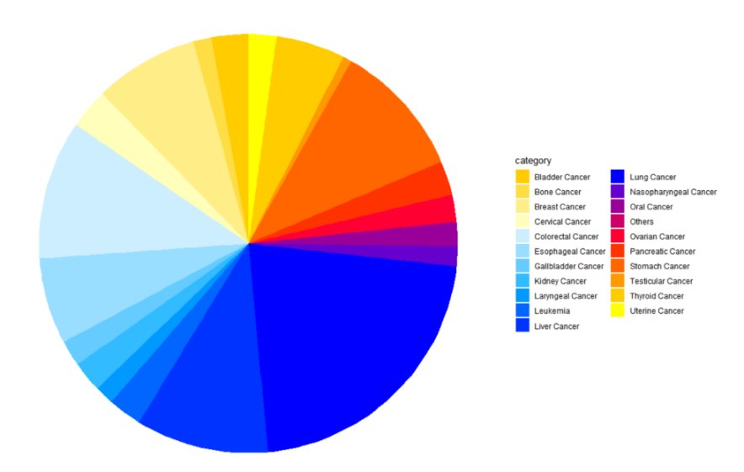

**Figure X Title for the image**

**Table X Title for the table**

| Variable | Estimate | Std..Error | t.value | Pr...t.. | Significance |
| --- | --- | --- | --- | --- | --- |
| (Intercept) | -1.256611e+04 | 2.810928e+02 | -4.470449e+01 | 0.000000e+00 | *** |
| Employment_Rate | 7.520958e-03 | 4.441065e-03 | 1.693503e+00 | 9.036613e-02 | . |
| factor(SEX)WOMEN | -1.441631e+00 | 2.692860e-01 | -5.353531e+00 | 8.664150e-08 | *** |
| TIME | 6.238252e+00 | 1.392204e-01 | 4.480846e+01 | 0.000000e+00 | *** |

Note: Detailed description and annotation for the image/table

 (1)

**4|Results and Discussion**

This section is a comparative or descriptive analysis of the study based on the study results, previously literature, etc. The results should be offered in a logical sequence, given the most important findings first and addressing the stated objectives. The author should deal only with new or important aspects of the results obtained. The relevance of the findings in the context of existing literature or contemporary practice should be addressed.

**4|Conclusion**

The author should clearly explain the important conclusions of the research highlighting its significance and relevance.

**Funding**

Please add: “This research received no external funding” or “This research was funded by NAME OF FUNDER, grant number XXX” and “The APC was funded by XXX”.

**Conflicts of Interest**

Declare conflicts of interest or state “The authors declare no conflict of interest.”

**ORCID iD (if any)**

**References**

References to the work should follow the 7th APA style and carefully checked for accuracy and consistency. Please ensure that every reference cited in the text is also present in the reference list and vice versa.

1. List the reference here
2. List the reference here

......

List the reference here